**Assignment No. 1**

**Code:-**

import numpy as np

import matplotlib.pyplot as plt

import pandas as pd

from sklearn.cluster import KMeans

X=[[0.1,0.6],[0.15,0.71],[0.08,0.9],[0.16,0.85],[0.2,0.3],[0.25,0.5],[0.24,0.1],[0.3,0.2]]

centroids=np.array([[0.1,0.6],[0.25,0.5]])

kmeans=KMeans(n_clusters=2,init=centroids)

kmeans.fit(X)

print("Labels after trainig:",kmeans.labels_)

#Q1

print("P6 belongs to ",kmeans.labels_[5],"cluster")

#Q2

print("Population around centroid 2(P6) is ",np.count_nonzero(kmeans.labels_==1))

#Q3

print("New values of centroids are:",kmeans.cluster_centers_)

from sklearn import datasets

iris=datasets.load_iris()

iris_x=iris.data

wcss=list()

for i in range(1,11):

kmeans=KMeans(n_clusters=i,init='k-means++')

kmeans.fit(iris_x)

wcss.append(kmeans.inertia_)

plt.plot(range(1,11),wcss)

plt.xlabel('No. of clusters')

plt.ylabel('WCSS')

plt.show()

kmeans=KMeans(n_clusters=3,init='k-means++')

kmeans.fit(iris_x)

y_means=kmeans.predict(iris_x)

plt.scatter(iris_x[y_means==0,0],iris_x[y_means==0,1],c='blue',s=100,label='iris_sertosa')

plt.scatter(iris_x[y_means==1,0],iris_x[y_means==1,1],c='yellow',s=100,label='iris_versicolour')

plt.scatter(iris_x[y_means==2,0],iris_x[y_means==2,1],c='green',s=100,label='iris_versginica')

plt.scatter(kmeans.cluster_centers_[:,0],kmeans.cluster_centers_[:,1],c='red',s=100,label='centroids')

plt.legend()

plt.show()

**Output:-**

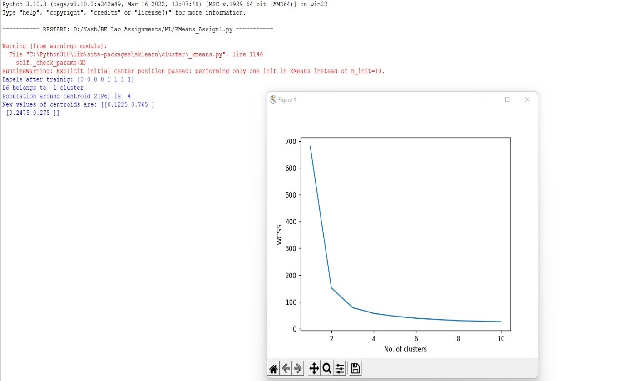

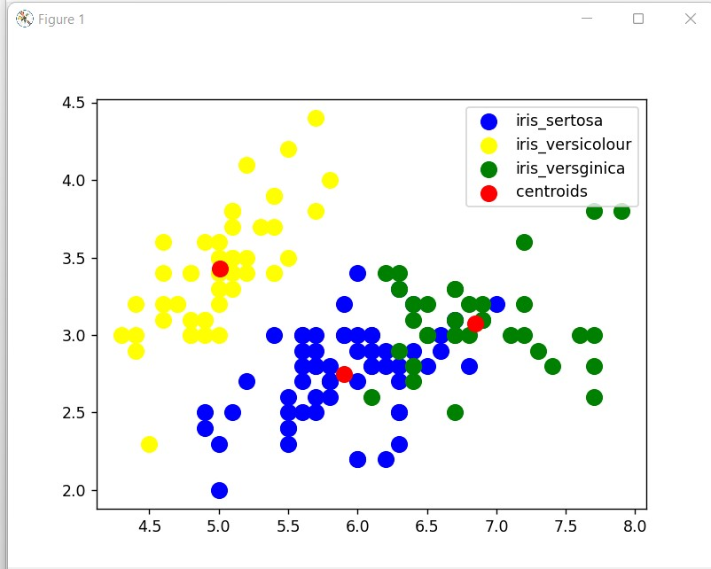

**Assignment No. 3**

**Code:-**

from sklearn.linear_model import LinearRegression

import matplotlib.pyplot as plt

import pandas as pd

from sklearn.datasets import load_diabetes

from sklearn.linear_model import LinearRegression, Ridge

from sklearn.model_selection import cross_val_score

diabetes = load_diabetes()

lr = LinearRegression(normalize = True)

lr_scores = cross_val_score(lr, diabetes.data, diabetes.target,cv=10)

print("Scores obtained by Linear Regression: ",lr_scores)

print("\nMean: ",lr_scores.mean())

***Output:-***

**Scores obtained by Linear Regression: [0.55614411 0.23056092 0.35357777 0.62190498 0.26587602 0.61819338**

**0.41815916 0.43515232 0.43436983 0.68568514]**

**Mean: 0.4619623619583371**

## Ridge

rg = Ridge(0.005, normalize=True)

rg_scores = cross_val_score(rg, diabetes.data, diabetes.target, cv=10)

print("Scores obtained by Ridge Regression: ",rg_scores)

print("\nMean: ",rg_scores.mean())

***Output:-***

**Scores obtained by Ridge Regression: [0.55014745 0.24000807 0.36373382 0.61657429 0.2695777 0.62172635**

**0.42346862 0.42813504 0.43117332 0.68303604]**

**Mean: 0.462758069707298**

## RidgeCV for set of alpha values, alpha_ to extract alpha value

from sklearn.linear_model import RidgeCV

rg = RidgeCV(alphas=(1.0, 0.1, 0.01, 0.005, 0.0025, 0.001, 0.00025),normalize=True)

rg.fit(diabetes.data, diabetes.target)

print(rg.alpha_)

rg_cv_scores = cross_val_score(rg, diabetes.data, diabetes.target, cv=10)

print("Scores obtained by RidgeCV Regression: ",rg_cv_scores)

print("\nMean: ",rg_scores.mean())

***Output:-***

**Scores obtained by RidgeCV Regression: [0.52803256 0.23657595 0.3565488 0.607513 0.2695777 0.62047382**

**0.42149214 0.43894932 0.43138195 0.6642474 ]**

**Mean: 0.462758069707298**

## Lasso, LassoCV

from sklearn.linear_model import Lasso, LassoCV

ls = Lasso(alpha=0.005, normalize=True)

ls_scores = cross_val_score(ls, diabetes.data, diabetes.target, cv=10)

print("Scores obtained by Lasso Regression: ",ls_scores)

print("\nMean: ",ls_scores.mean())

***Output:-***

**Scores obtained by Lasso Regression: [0.55078146 0.23993097 0.36453647 0.61454396 0.26894036 0.62269952**

**0.42465645 0.42726522 0.43075777 0.68414508]**

**Mean: 0.46282572553668555**

from sklearn.linear_model import LassoCV

ls_cv = LassoCV(alphas=(1.0,0.1,0.01,0.005,0.0025,0.001,0.00025),normalize=True)

ls_cv.fit(diabetes.data, diabetes.target)

ls_cv.alpha_

ls_cv_scores = cross_val_score(ls_cv, diabetes.data, diabetes.target,cv=10)

print("Scores obtained by LassoCV Regression: ",ls_cv_scores)

print("\nMean: ",ls_cv_scores.mean())

***Output:-***

**Scores obtained by LassoCV Regression: [0.51796189 0.23824666 0.35415718 0.59752149 0.27503201 0.62269952**

**0.41851368 0.42047653 0.42562829 0.68231416]**

**Mean: 0.45525514142746404**

## ElasticNet, ElasticNetCV

from sklearn.linear_model import ElasticNet, ElasticNetCV

en = ElasticNet(alpha=0.001,l1_ratio=0.8, normalize=True)

en_scores = cross_val_score(en, diabetes.data, diabetes.target, cv=10)

print("Scores obtained by ElasticNet Regression: ",en_scores)

print("\nMean: ",en_scores.mean())

***Output:-***

**Scores obtained by ElasticNet Regression: [0.53103739 0.24682675 0.38160097 0.60832995 0.2830996 0.62083992**

**0.43113636 0.43484866 0.43055758 0.6676087 ]**

**Mean: 0.46358858847836454**

encv = ElasticNetCV(alphas=(0.1, 0.01,0.005, 0.0025, 0.001),l1_ratio=(0.1,0.25,0.5,0.75,

0.8), normalize=True)

encv.fit(diabetes.data, diabetes.target)

print(encv.alpha_)

print(encv.l1_ratio_)

encv_scores = cross_val_score(encv, diabetes.data, diabetes.target,cv=10)

print("Scores obtained by ElasticNetCV Regression: ",encv_scores)

print("\nMean: ",encv_scores.mean())

***Output:-***

**Scores obtained by ElasticNetCV Regression: [0.52796681 0.24682675 0.38160097 0.60743123 0.28526958 0.61931497**

**0.43113636 0.43907824 0.43137097 0.66429212]**

**Mean: 0.46342880159848276**

## Comparative analysis

#Linear Regression Score

print(lr_scores.mean())

#Ridge Score

print(rg_scores.mean())

#Lasso Score

print(ls_scores.mean())

#ElasticNet Score

print(en_scores.mean())

***Output:-* 0.4619623619583371**

**0.462758069707298**

**0.46282572553668555**

**0.46358858847836454**

import matplotlib.pyplot as plt

import numpy as np

objects = ('Linear','Ridge','Lasso','ElasticNet')

y_pos = np.arange(len(objects))

p = [0.4619623619583371,0.4627580697072979,0.4628257255366856,0.46358858847836454]

plt.bar(y_pos, p, align='center',alpha=0.5, color=['hotpink', 'yellow', 'lime','cyan'])

plt.xticks(y_pos, objects)

plt.ylabel('Accuracy')

plt.title('Linear Models')

ElasticNetCV(alphas=(0.1, 0.01, 0.005, 0.0025, 0.001),

l1_ratio=(0.1, 0.25, 0.5, 0.75, 0.8), normalize=True)

plt.show()

***Output:-***

